4. SYSTEM DESIGN
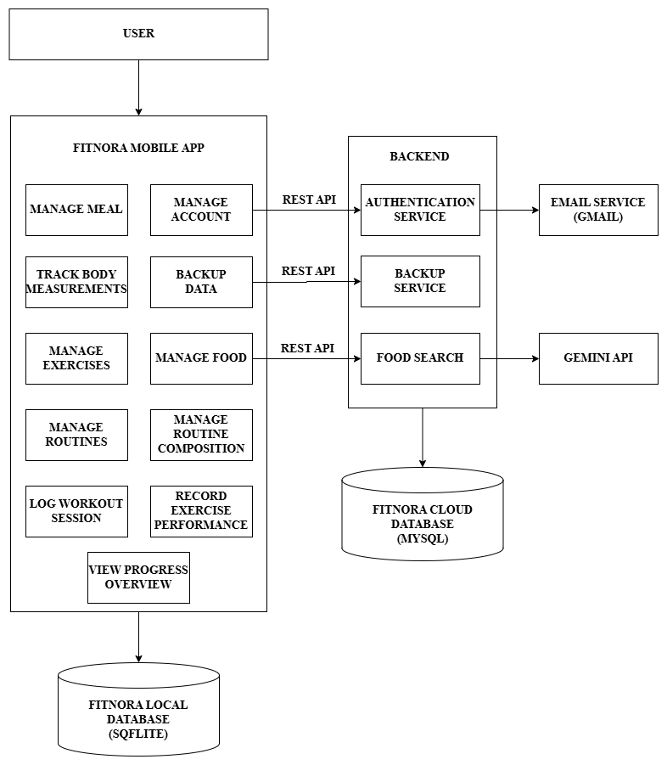
4.1 ARCHITECTURAL DESIGN
4.2 DATA FLOW DIAGRAM
DFD Level 0:
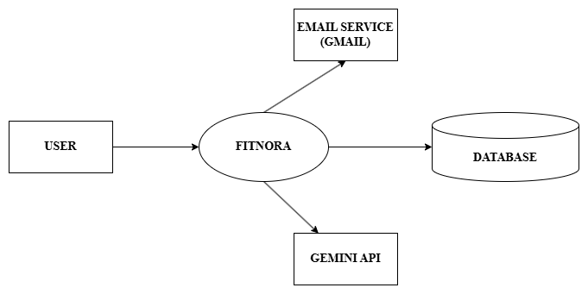

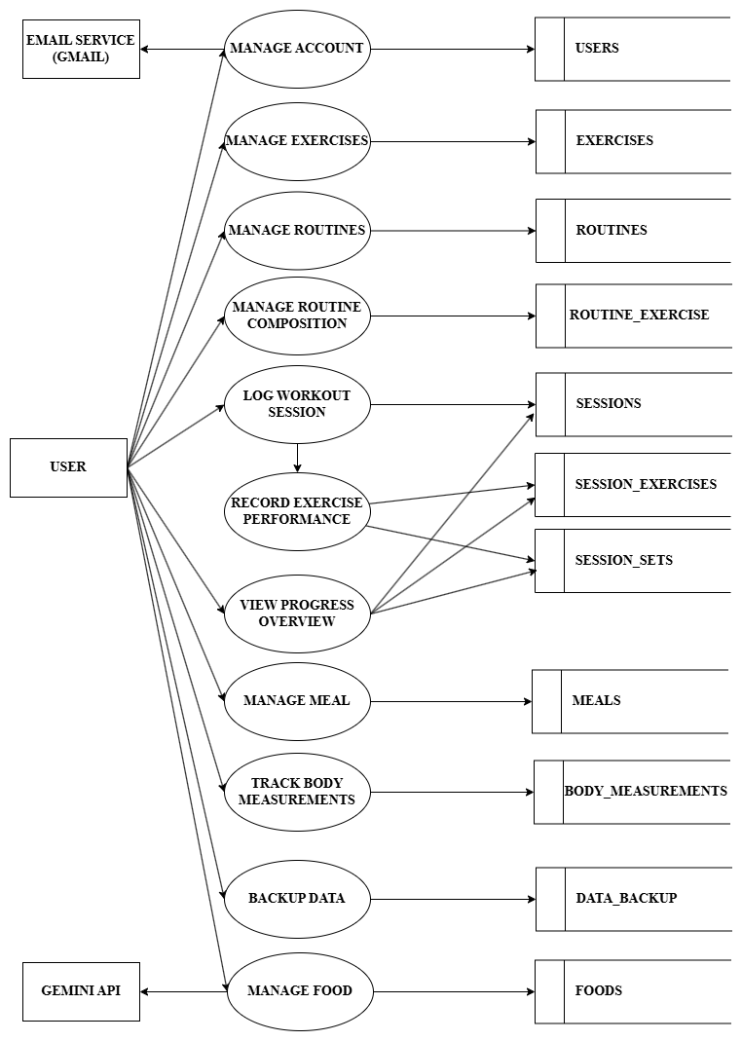
DFD Level 1:

4.3 DATA DICTIONARY
Table name: users
Purpose: To store the details of the user
S. No. | Field Name | Data Type | Constraint | Description
1 | user_id | Integer | Primary Key, Auto Increment | User unique id
2 | user_email | Varchar (255) | Not Null, Unique | User email
3 | user_fullname | Varchar (100) | Not Null | User full name
4 | user_dob | Date | Not Null | User date of birth
5 | password_hash | Text | Not Null | User hashed password
6 | gender | Varchar (20) | Not Null | User gender
7 | backup_enabled | Boolean | Not Null, Default | Is backup enabled
8 | updated_at | Timestamp | Not Null, Default | Record updated timestamp

Table name: data_backup
Purpose: To store the backup files
S. No. | Field Name | Data Type | Constraint | Description
1 | data_backup_id | Integer | Primary Key, Auto Increment | Data backup unique id
2 | user_id | Integer | Foreign Key, Cascade | User id from ‘users’
3 | user_dbfiles | Text | Not Null | Path for user’s db files
4 | user_images | Text | Not Null | Path for user’s images
5 | updated_at | Timestamp | Not Null, Default | Record updated timestamp

Table name: exercises
Purpose: To store the exercises of the user
S. No. | Field Name | Data Type | Constraint | Description
1 | exercise_id | Integer | Primary Key, Auto Increment | Exercise unique id
2 | exercise_name | Text | Not Null, Unique | Exercise name
3 | exercise_image | Text | Not Null | Exercise image
4 | exercise_equipment | Text | Not Null | Used exercise equipment
5 | exercise_mode | Text | Not Null | Reps or Timer
6 | is_deleted | Integer | Not Null, Default | To soft delete exercise
7 | updated_at | Integer | Not Null | Record updated timestamp

Table name: routines
Purpose: To store the routines of the user
S. No. | Field Name | Data Type | Constraint | Description
1 | routine_id | Integer | Primary Key, Auto Increment | Routine unique id
2 | routine_name | Text | Not Null, Unique | Routine name
3 | is_deleted | Integer | Not Null, Default | To soft delete routine
4 | updated_at | Integer | Not Null | Record updated timestamp

Table name: routine_exercises
Purpose: Used to map the exercises to routines
S. No. | Field Name | Data Type | Constraint | Description
1 | routine_exercise_id | Integer | Primary Key, Auto Increment | Exercise unique id
2 | routine_id | Integer | Foreign Key, On Delete Cascade | Routine id from ‘routines’
3 | exercise_id | Integer | Foreign Key, On Delete Cascade | Exercise id from ‘exercises’
4 | exercise_order | Integer | Not Null | Used to store the order of the exercises

Table name: sessions
Purpose: To store the workout sessions of the user
S. No. | Field Name | Data Type | Constraint | Description
1 | session_id | Integer | Primary Key, Auto Increment | Session unique id
2 | routine_id | Integer | Foreign Key, On Delete Cascade | Routine id from ‘routines’
3 | executed_date | Date | Not Null | Routine executed date
4 | started_at | Integer | Not Null | Starting Time
5 | ended_at | Integer | Not Null | Ending Time

Table name: session_exercises
Purpose: To store the session’s exercises of the user
S. No. | Field Name | Data Type | Constraint | Description
1 | session_exercise_id | Integer | Primary Key, Auto Increment | Session exercise unique id
2 | session_id | Integer | Foreign Key, On Delete Cascade | Session id from ‘sessions’
3 | exercise_id | Integer | Foreign Key, On Delete Cascade | Exercise id from ‘exercises’
4 | exercise_order | Integer | Not Null | Exercise executed order

Table name: sessions_sets
Purpose: To store the workout session’s sets of the user
S. No. | Field Name | Data Type | Constraint | Description
1 | set_id | Integer | Primary Key, Auto Increment | Set unique id
2 | session_exercise_id | Integer | Foreign Key, On Delete Cascade | Session exercise id
3 | reps | Integer | - | Reps executed
4 | duration | Integer | - | Duration in seconds
5 | weight | Real | - | Weights used

Table name: foods
Purpose: To store the food items of the user
S. No. | Field Name | Data Type | Constraint | Description
1 | food_id | Integer | Primary Key, Auto Increment | Food unique id
2 | food_name | Text | Not Null, Unique | Food name
3 | food_calories | Real | Not Null | Food calories for 100g
4 | food_protein | Real | Not Null | Food protein for 100g
5 | food_carbs | Real | Not Null | Food carbs for 100g
6 | food_fats | Real | Not Null | Food fats for 100g
7 | food_fibers | Real | Not Null | Food fibers for 100g
8 | food_source | Text | Not Null | User created or Gemini AI
9 | updated_at | Integer | Not Null | Record updated timestamp

Table name: body_measurements
Purpose: To store the body measurement progress of the user
S. No. | Field Name | Data Type | Constraint | Description
1 | measurement_id | Integer | Primary Key | Measurement unique id
2 | user_image | Text | Not Null | Image of the user
3 | user_weight | Real | Not Null | Weight of the user
4 | user_height | Real | Not Null | Height of the user
3 | recorded_at | Date | Not Null | Recorded date
4 | updated_at | Integer | Not Null | Record updated timestamp

Table name: meals
Purpose: To store the meals eaten by the user
S. No. | Field Name | Data Type | Constraint | Description
1 | meal_id | Integer | Primary Key | Food unique id
2 | food_id | Integer | Foreign Key, On Delete Cascade | Food name
3 | meal_date | Date | Not Null | Meal eaten date
3 | meal_type | Text | Not Null, Check | Breakfast, lunch, dinner or snacks
4 | meal_quantity | Real | Not Null | Quantity of meal taken
5 | meal_calories | Real | Not Null | Food calories
6 | meal_protein | Real | Not Null | Food protein
7 | meal_carbs | Real | Not Null | Food carbs
8 | meal_fats | Real | Not Null | Food fats
9 | meal_fibers | Real | Not Null | Food Fibers
10 | updated_at | Integer | Not Null | Record updated timestamp

